Case Study 8
Profile of M/s SHS
Name of the Enterprise | M/s SHS
Managing Director | KK
Constitution | Private Limited Company
Factory Address | Hyderabad
Established | 2014
Line of Activity | Encapsulating of Ayurvedic food supplements and softgel  capsules
Udyog Aadhar
GST

- Line of Activity
Entrepreneur engaged in encapsulating Ayurvedic food supplements and softgel capsules.

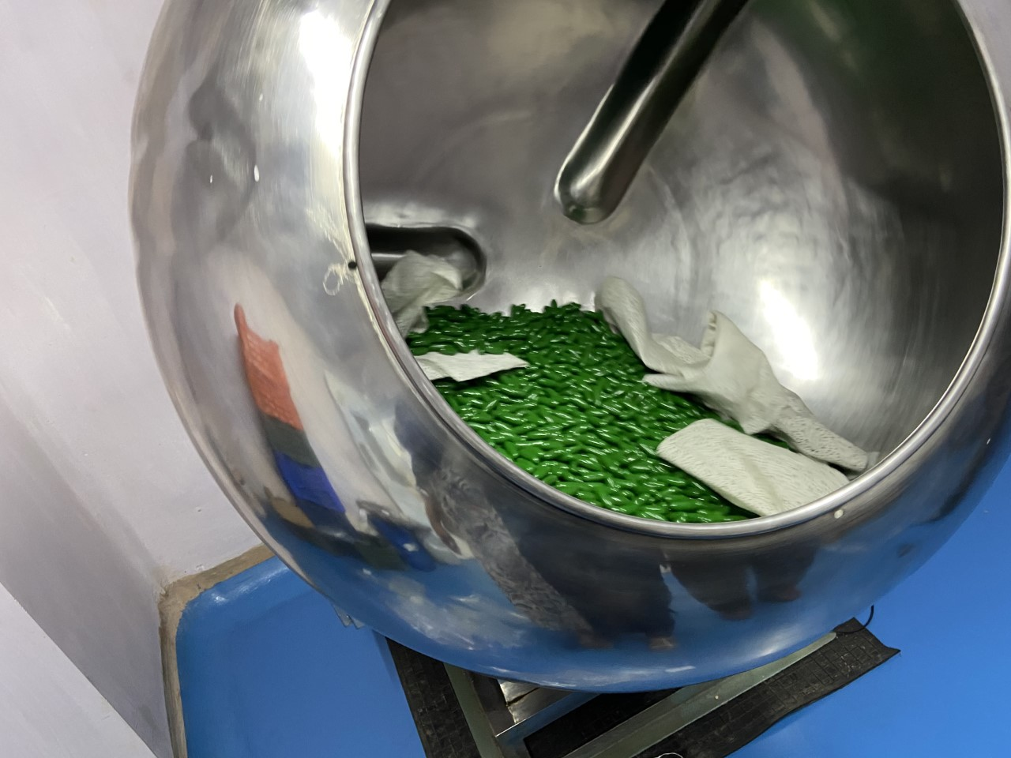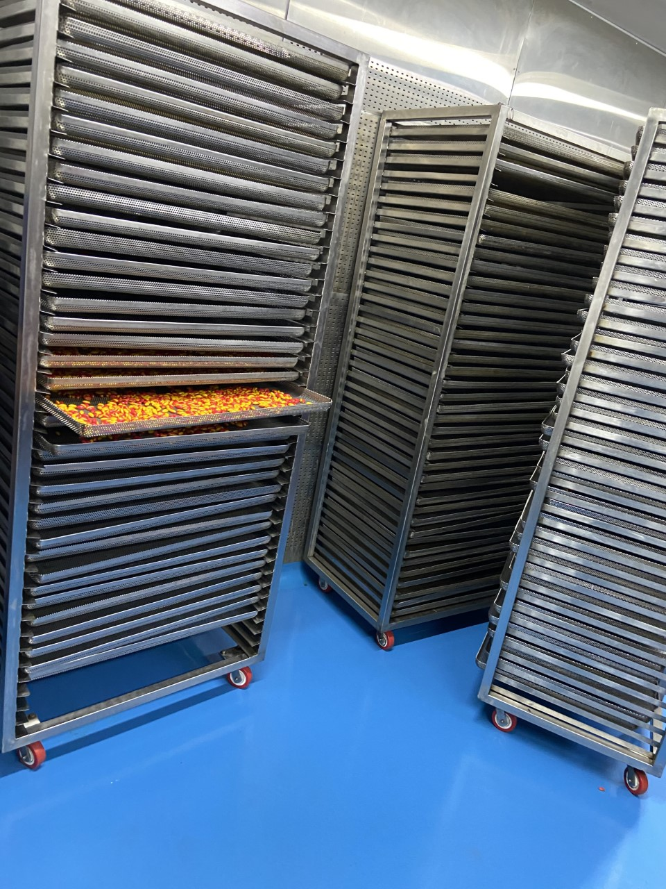

- Managerial Competencies
The MD Mr. KK is well educated, he received postgraduation degree from IIM Bangalore in the year 2009. He has worked as vice president in Planman Consulting India Pvt Ltd for 5 years. To pursue his entrepreneurial ambition he has stared this company in the year 2014

- Machinery/ Manufacturing Process
Entrepreneur engaged in encapsulating Ayurvedic food supplements and soft gel capsules. The unit has distinguished machines to heat and liquify gelatine, encapsulating the vitamins, drying the capsules, and packing the capsules. The company buys input materials from M/s SPC, Kasthubha Herbal & Neutri care, Fenoplast limited, etc.
.
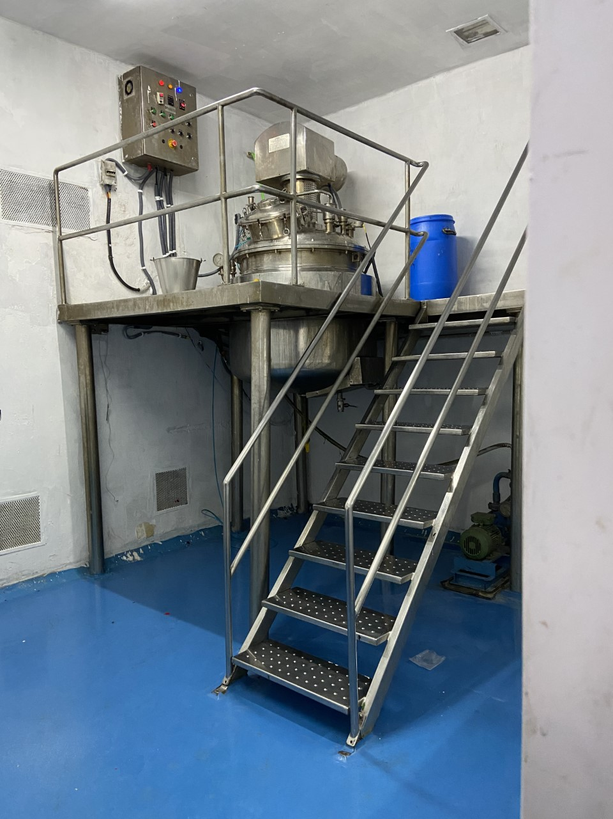

- Marketing
The company has continuous orders from companies like Arya Vaidya Pharmacy (Coimbatore) Ltd; Bio Ace Pharmaceuticals; Avn Ayurveda Formulations Pvt Ltd; Genome Therapeutics Private Limited; Kayakalpa Ayurveda
- TIHCL Intervention
The unit was sanctioned a Term loan of ₹ 22 million by Mahesh Bank in 2014 and has current account with ICICI Bank. There are no formal working capital limits. The unit ran into problems on account of a fire accident that took place in the factory for which the insurance company is yet to settle the claim. In the meanwhile, the Account became NPA in the books of the Bank.

To pay of the dues Client has approached TIHCL for early release of sanctioned incentive.

TIHCL has diagnosed the enterprise and identified following reasons of sickness
- Delay in initial phase of company in obtaining licence. Due to delay in licence the production plans hampered
- Introduction of GST had few hiccups for few months
- A fire accident took place in the factory. The company has invested ₹8.8 million for the casualty and the damaged infrastructure such as electrification. Due to delay in insurance the customer has to pay from the internal cash flows.
- Investment Subsidy was sanctioned in 2017 the funds are yet to be released
- Non-receipt of PAVALA VADDI and POWER SUBSIDY
- No apt financial planning
- Dispute with insurance company in claim
While the process for priority release of incentive is on, Mahesh Bank is pressurizing the unit to pay overdue interest and instalments amounting to ₹ 1.6 million, failing which they threatened to take further steps like legal action etc, TIHCL sanctioned bridge loan against sanctioned investment subsidy to save the unit.
Key Indicators | Pre-Revival | Post TIHCL Intervention
No of EMIs pending with primary lender | 8 | 0
Capacity Utilization | 25% | 60%
Turnover | ₹ 18.3 millions | ₹ 44.0 million (Annualised)
Employment | 50 persons | 50 persons

- Labour Status
Gender | Skilled | Unskilled
Men | 22 | 02
Women | 21 | 05
Total | 43 | 07

Livelihood: At 60% of the capacity they have employed 50 workers and their families are dependent on this enterprise which is around 250 individuals including entrepreneurs. The employed workers are sufficient to run at full capacity; the idle time of workers will be reduced.

